Actions for this week:
Continue revising the proposal, train and test baseline models on the RealWorld dataset, and prepare to start preprocessing the LARa dataset.

What did I do this week? Why did I do this?
1. Rushed to send the revised third draft of my proposal to Dr Halloran before midday on 13 October.
2. Trained and tested six baseline models (kNN, Random Forest, InceptionTime, MiniRocket, MultiRocket and Time Series Transformer) on the fully preprocessed RealWorld dataset and inspected the results.
3. Prepared to start the preprocessing of the LARa dataset.

Why:
1. Last Friday (10 October), my supervisor said: “Happy to look again on Monday.” I wanted to send the draft before midday because he had previously said it is best if proposal drafts reach him by around noon, so that he has time to review them. In addition, the submission deadline was 18:00 on the 13th. Although there was a grace period until the 14th, it is always better to finish earlier.
2. This is the most natural and essential step after preprocessing the dataset. At the most basic level, my project consists of two parts: first, preprocessing the dataset; second, training and testing models on it and reporting their accuracy. This is what my supervisor described as the core goal. Using more baseline models, more complex experiments and deeper analysis belongs to the stretch goals. I need to make sure I first complete the core, minimum objectives properly, and only then think about the stretch goals.
3. If I only used one dataset for all experiments, the results would be far less convincing. A model might perform well on one dataset but badly on another. Using two different datasets with some differences between them allows me to show the strengths and weaknesses of models more clearly and in more depth, and also provides stronger evidence when I later evaluate my own proposed model.

Outcomes and findings:
1. My supervisor said that compared with earlier versions, my proposal has improved a lot. However, the phased plan (p.5) is still too dense, and I have exceeded the word limit by quite a margin. He also pointed out that, at the moment, I am constructing the literature review backwards: I first fixed my own problems/topics, and then tried to “reverse engineer” a literature review to support these questions. This is the wrong way round. The correct order should be that the literature review drives and guides which problems and topics I choose to focus on.
2. I found that kNN, Random Forest, InceptionTime and TST were relatively quick to produce results. kNN and Random Forest are not very complex models, and InceptionTime can be trained using the GPU. MiniRocket and MultiRocket, however, were very slow. So far, I have only managed to complete three folds of MiniRocket, and not even a single fold of MultiRocket. In contrast, the other models have already finished all 15 LOSO folds on RealWorld.

Explanation:
The RealWorld-HAR dataset has 15 subjects in the official setup. Under a LOSO protocol, we treat the 15 subjects as 15 folds:

Fold 1: S1 as test, the other 14 as train
Fold 2: S2 as test, the other 14 as train
…
Fold 15: S15 as test, the other 14 as train

In this setting: number of subjects = number of LOSO folds = 15.

Leave-One-Subject-Out (LOSO): in each fold we hold out one participant’s data entirely for testing, train on all remaining participants, and repeat until every participant has served as the test fold; metrics are then aggregated across folds.

3. The preprocessing of the LARa dataset was delayed by a day or two, and I only started on it while MiniRocket and MultiRocket were still training. This is because I had been thinking about whether there was any way to speed up MiniRocket and MultiRocket training. On CPU, both of these models are extremely slow.

Reflection:
1. I had been revising the proposal continuously for several days (from 10 to 13 October), yet my supervisor still said there were problems. I felt very tired, but with the submission deadline so close, I could only push through and improve as much as possible before resting.

2. Last semester, when I trained MiniRocket on PAMAP2, it already took a long time compared with other models. This time, the RealWorld dataset is much more complex than PAMAP2. I only had three realistic options:

1. Just wait patiently for MiniRocket to finish training.
2. Drop MiniRocket and the even slower MultiRocket from the experiments.
3. Look for ways to speed up training.

After thinking carefully, I summarised the pros and cons of these three options.
Option 1 would eventually finish MiniRocket, but I would have to keep Colab running in the background, which sometimes interferes with other tasks and uses up laptop memory. Also, if I later want to change the code or add new features (for example, more visual output), I would have to retrain everything. And even with this “just wait” approach, I still would not have a solution for MultiRocket, which is several times slower than MiniRocket.
Option 2 would make my life much easier, but at the cost of losing a very important baseline. MiniRocket is a strong, lightweight and efficient baseline in recent years. Dropping the whole Rocket family would significantly reduce the value of my work.
Option 3 involved looking for techniques to accelerate training while preserving experimental quality.

In the end, I chose option 3. By using multi-core CPUs and multi-threading to run MiniRocket, parallelising different folds, caching Rocket features so they were computed once and reused, and carefully reducing redundant cross-validation computations, I successfully completed all 15 folds for MiniRocket on the RealWorld dataset. As in my previous semester’s work, MiniRocket is not the most accurate model, but it offers the best balance between speed, compactness and accuracy. I also reduced the number of features and kernels in MiniRocket slightly to speed up training, but this did not harm experimental quality; in fact, it even aligns better with the setups used in some top conference/journal papers.

However, even after using almost all feasible acceleration tricks, MultiRocket is still extremely slow. After looking up more information, I found that this is normal and that many researchers encounter the same issue. One workaround is to use the tsai implementation of MultiRocket, which can run on the GPU and thus train faster. But the drawback is that it no longer aligns with prior work, because many past studies used the CPU-based (sktime) versions of MiniRocket and MultiRocket. For now, I have decided to put MultiRocket on hold and focus on preparing the LARa preprocessing.

3. I learned that the LARa dataset is inherently a multimodal dataset: it includes RGB video, motion capture (3D skeleton) and wearable IMU data. Because time is limited in an MSc project, I chose to use only the wearable IMU part of LARa. Handling all modalities would require decoding MP4/AVI video and a series of other complex steps, and the preprocessing time would be roughly 10–20 times that of IMU-only processing.

Finally, I also applied some statistical methods to compare differences between models, and I performed sensitivity and robustness analysis specifically for MiniRocket, as well as error analysis for other models. I will describe these in detail in the dissertation.

Have I finished this week’s action? What percentage? If not, how to improve?
Completion rate: 90 percent.
MultiRocket has not yet completed all folds on the RealWorld dataset. I will first complete the preprocessing of the LARa dataset and then see how MultiRocket performs on LARa.

Actions for next week:
Finish preprocessing the LARa dataset and train/test several baseline models on it. Begin preparing the work needed to design a new model.

Email record with my supervisor, Halloran:
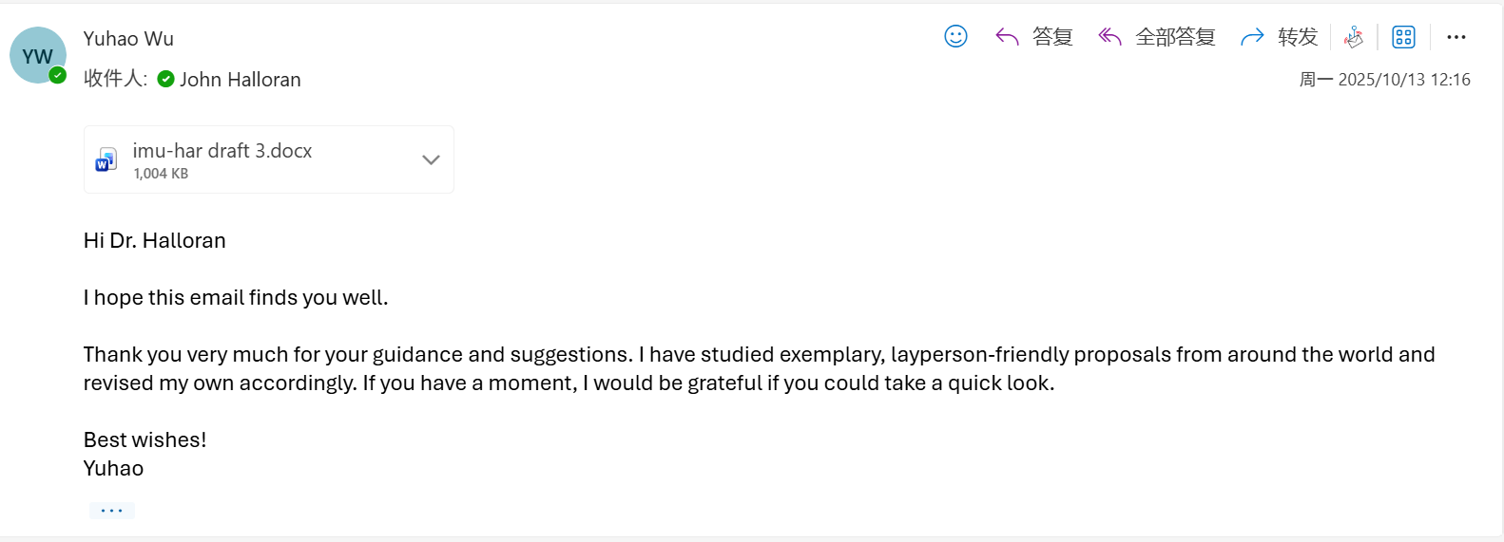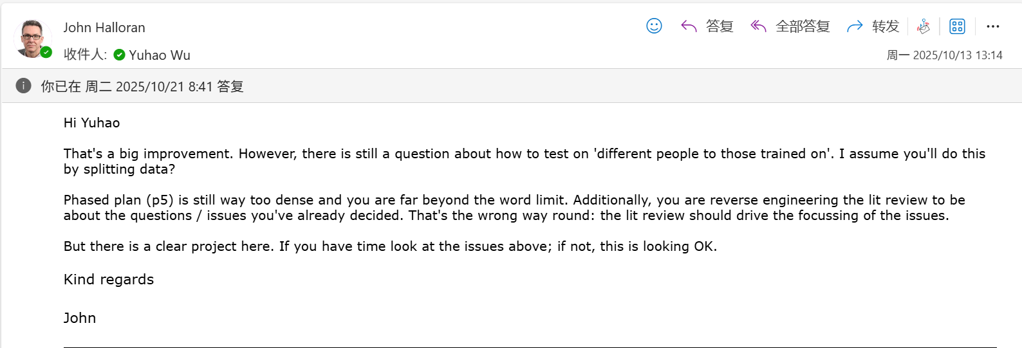
In accordance with my supervisor’s requirements, I revised and completed the fourth version of the proposal.
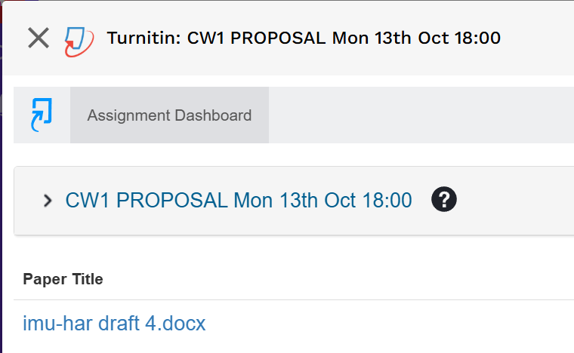

Meeting part:
Messages from my supervisor, John Halloran.
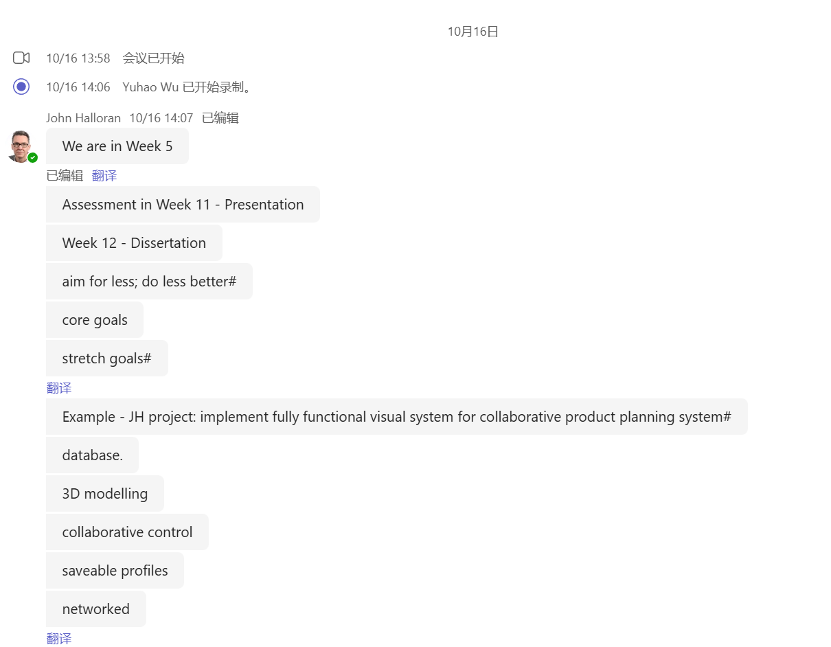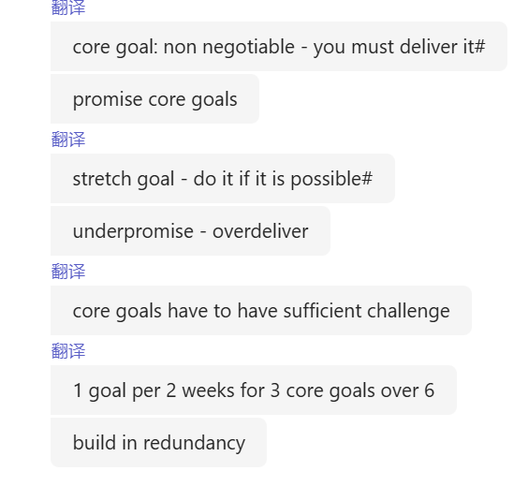

I asked my supervisor, John Halloran, two questions.
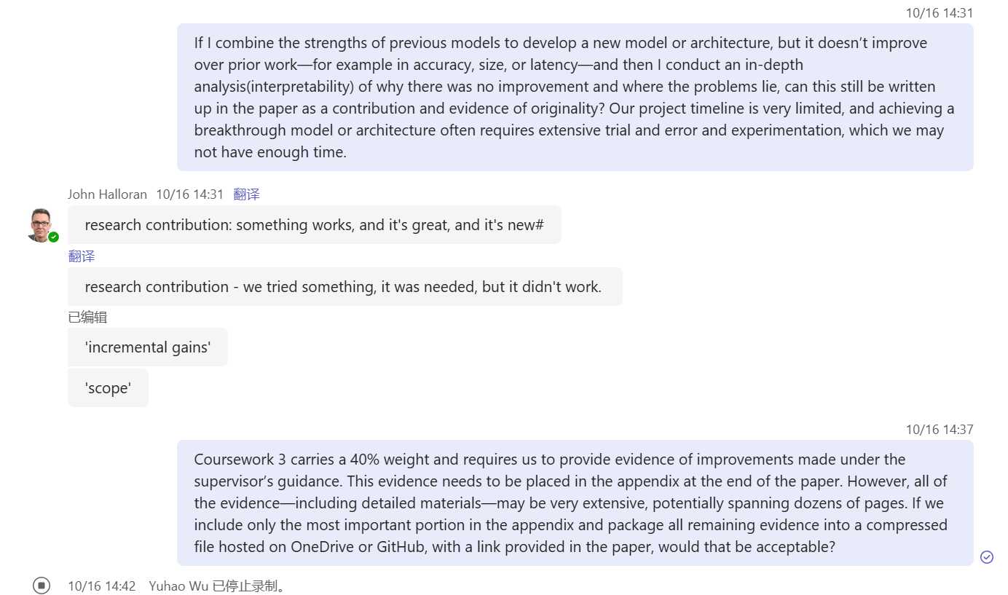
His answer to my first question was:
“Very good. Yes, that is fine. Basically there are two types of research contribution. The first type is: what we have done works, it is new, and it is excellent. That is the ideal contribution. The second type is this: we try something that is necessary to try, but it does not succeed. Many people think that if the result is ‘we tried but it did not work’, then it has no value. In fact, it has enormous value, because you are telling everyone: this path does not work for you. And we also explain why it does not work, which is still good research.

So the first type is ‘positive’, a positive discovery. The second type is ‘negative’, but the negative result is good because it tells us not to go down that route and that we should try a different one, do you see?

Another question is: what counts as ‘new’? As researchers you are required to do something ‘new’. Achieving something completely new is actually very difficult. Most research is not entirely novel; it builds on the work of others. That is called incremental gains. You cannot change the whole world, but you can move forward step by step.

For example, suppose you are doing research on neural networks and you are very concerned about overfitting. We already understand neural networks and we know that overfitting occurs. But you want to develop a new way of finding a good balance to avoid overfitting. There are many ideas about this. You review these ideas and then say: I will make a small modification to one of these approaches, only a slight change. Perhaps you make a simple adjustment to the network architecture, or change its biases.

You might also deliberately choose simple neural networks (for example, non-convolutional ones) and work only within that space. Then your research scope becomes focused: in a particular problem space, with a particular type of network, you concentrate on overfitting. That is already enough, and more than enough.

This is what ‘new’ means: it has not been done before. ‘New’ does not mean that everything must be new. That is unrealistic. Most research advances in small steps. The research that ‘changes the world’ is the famous work. For example, the invention of the internet, or generative AI becoming a consumer product in the form of ChatGPT. Those things change the world, but they are rare. Einstein’s E = mc² is another example. These works changed the world, but they are not the norm in research; they are breakthrough results. They are not what you are expected to achieve, so you do not need to worry about that, okay?

You are just one person, you only have seven weeks, and you are a student. So you need to look for some small but original element, something you can identify as necessary to do, and then show us how you explored that area or space.”

My improvement: If in the end I do not succeed in developing a model that clearly improves on existing ones, I will still treat my own “failed” model, which combines strengths of mainstream or state-of-the-art models, as a contribution in the dissertation, but I will need to include in-depth analysis explaining why this approach did not lead to improvements.

His answer to my second question was:
“That is absolutely right. You are completely correct: the amount of evidence can become very large. As you can see, this meeting is being recorded. That is fine. In future, when you and I meet one-to-one, you can also record the session; that is no problem. You can put these recordings on OneDrive and then include links to them in your report.

You are right that the evidence can become huge. You asked a very good question: how much should go into the appendix? You are correct that some of it needs to go into the appendices. You can also put links in the appendix. That is exactly the obvious thing to do. By placing links there, you can reduce the complexity of the main text.

However, you must describe in the main text or in the appendix what each link points to and why it is important. In other words, you need a summary or overview. For example, you might have ten links to one-to-one supervisions, numbered 1–10. Then, in the appendix, you provide a short summary for each supervision.

You can also include a table for this. For each meeting, you note: what materials did you bring? What was discussed? What questions were asked? How were those questions answered? What are the next steps? Put all of this into a summary table for each supervision.

Now, there is also the question of GitHub, right? If you are using GitHub, the most direct approach is to write a README that explains the contents of the repository. Then, in your report, you can reuse the README or write a brief overview. The key point is: do not just drop a link in without any context or explanation. That is something I am going to teach you as well.

This is a very good question. Appendices are sometimes too large, sometimes too small. They are often too small because students only include links without explaining what those links are; that is usually related to lack of time, so they just throw links in at the end.”

My improvement: I now document the project process in detail on GitHub.
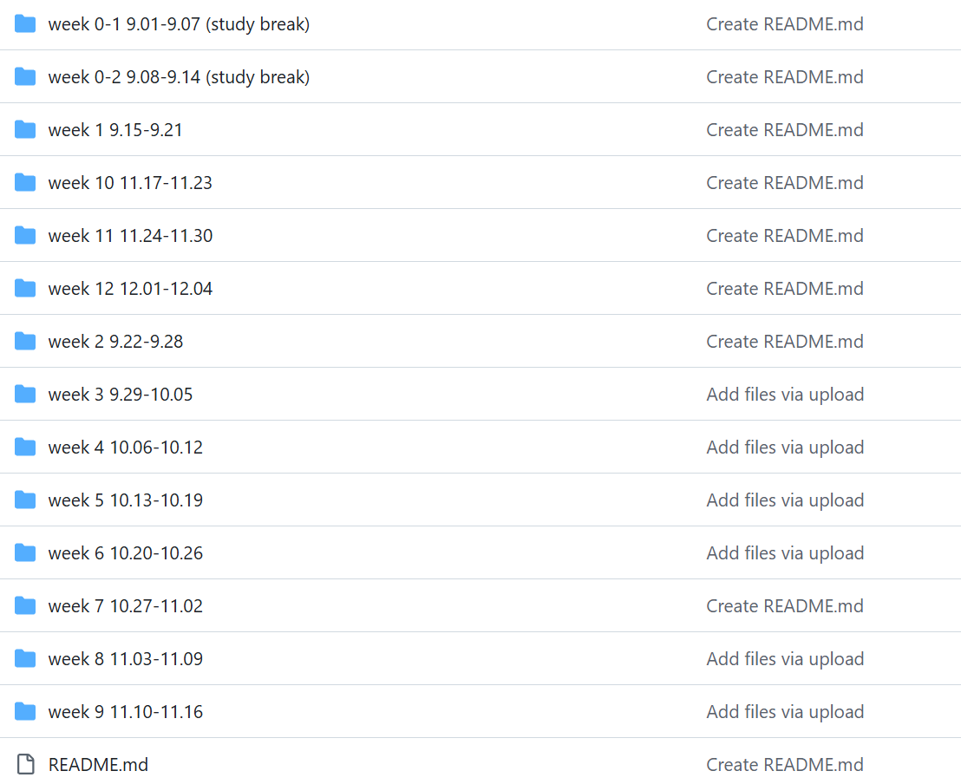
In addition, my supervisor gave us another suggestion:
“There is another very good idea you can use right now: first, find a dissertation template. Once you have the template, put in your title and your name. Then write the section headings and put at least one paragraph under each heading. That way, you have started; the dissertation ‘exists’. This is a very good practice. By the time you reach Week 11 and have to give your presentation, it will be much easier, because the presentation will be based on the dissertation.”

My action:
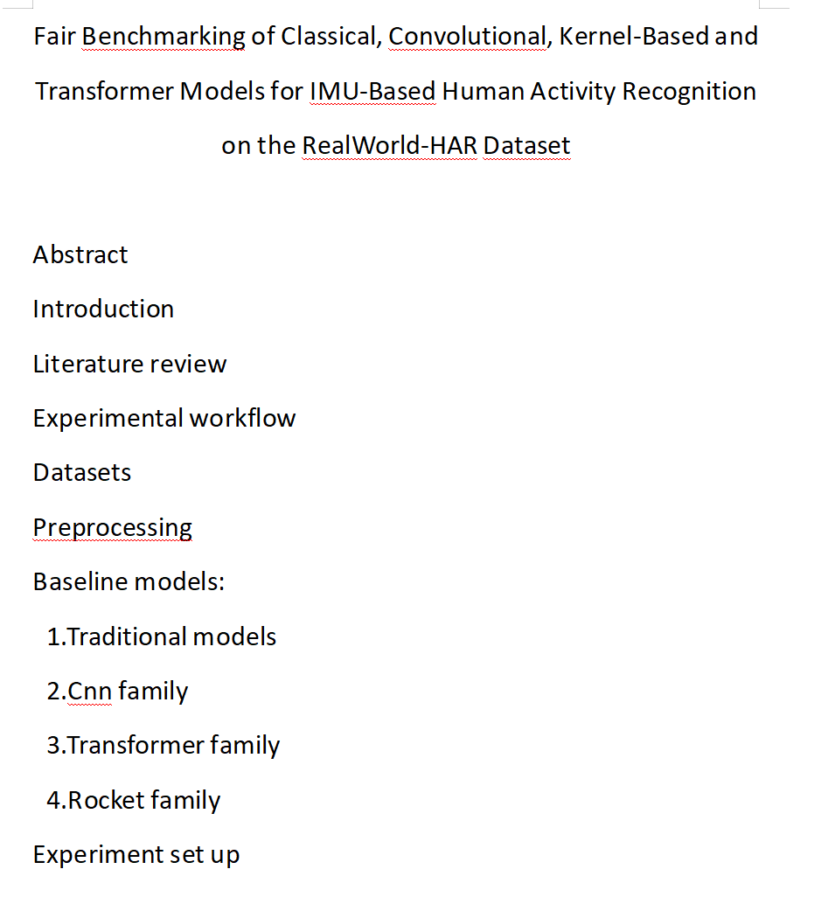

All important points my supervisor, John Halloran, has mentioned:
1. Timeline and assessment schedule
We are currently in Week 5. The presentation will be in Week 11 (about six weeks from now), and the dissertation will be submitted in Week 12 (about seven weeks from now).

Slides upload: 24 November. Only 5–6 slides are required. The slides themselves are not marked; uploading them is just the starting point of the process.

Live assessment (on Teams) will take place in the following week. There was a small confusion in the document about dates; the field should actually say 3/12. At that point, you will arrange a time slot with the two supervisors, and deliver a live presentation and Q&A based on your slides.

This module is worth 60 credits (much larger than the usual 15 or 30 credits), which is why you are only taking this module this term and why the workload and expectations are higher.

The supervisor will try to give an informal preview mark for the proposal (before the formal release of marks), very likely early next week.

2. Marking and weighting
Key points for the presentation: the talk plus the Q&A together account for 50%; the Q&A is particularly important.

For the dissertation:
40% = project process
30% = technical work (code/software)

Dr Halloran especially emphasised that the process mark is higher than the pure technical mark. He will keep reminding us how marks are allocated and what we must not forget to include.

3. Core goals and stretch goals
Core goal: non-negotiable and must be delivered.
Stretch goal: only attempted if there is time and it is feasible.

Principles:
Under-promise, over-deliver.
Do less, better.
Continuously narrow the scope where necessary.

Example (using a product configuration system to illustrate trade-offs):

Core (promisable):
Only 2D modelling, a small dummy database, a small number of saved configurations (e.g. 5), and no online connectivity.

Stretch:
3D modelling, a full database, unlimited configuration slots, and an online system.

4. Project management and scheduling
The plan should be built around the core goals; make sure the core deliverables are secured first.

Across the remaining 7 weeks, three core goals roughly mean one core goal every two weeks.

Allow redundancy: if you finish one goal early, use the extra time either to push the next core goal forward or to work on stretch items.

Start immediately. By the next supervision, you should at least be able to show a working environment or some initial results. Do not wait until next week to begin.

5. Supervisions and Q&A training
In each one-to-one supervision, the supervisor will deliberately train you on technical Q&A (aligned with the kinds of questions that may appear in the formal assessment):

How the code runs and what it does;
Why you chose particular libraries;
If you are doing machine learning: why you chose specific models, how those models work, whether they overfit, and how you handle overfitting.

Being unable to answer in supervisions does not lose marks, because supervisions are not graded. The purpose is to practise and improve your ability to answer questions, so you are prepared for the live presentation and Q&A.

From next week, supervisions are expected to switch to individual mode: around 20 minutes per person, with three students rotating within a one-hour block.

6. What counts as “research contribution” and “new”
Both of the following are valid forms of contribution:

Positive results: what you built works and is new.
Negative results: you tried something necessary, but it did not work, and you explain why it is not feasible. This can save other researchers from wasting time on the same path.

“New” usually means incremental gains: small, clear original improvements on top of existing work. You do not have to overturn everything.

Example: focus on overfitting in a restricted problem setting with simple (even non-convolutional) networks, make a small modification or bias adjustment, and evaluate it systematically. That already counts as sufficiently “new”.

You are not expected to produce world-changing breakthroughs (like the internet, ChatGPT as the first large-scale consumer generative AI product, or E = mc²). The realistic expectation is: one person, seven weeks.

7. Process evidence, record keeping, and use of appendices/links
Process evidence (worth 40%) includes:

Ongoing participation in supervisions and bringing material to discuss;
Having results each week and talking them through with the supervisor;
Recording feedback and improvements and keeping evidence of this.

Recording is allowed: the supervisor noticed the current session was being recorded and said one-to-one sessions can also be recorded. These recordings can be stored on OneDrive and cited via links in the dissertation.

Any link must be accompanied by context or a brief summary; avoid bare links.

For GitHub: prepare a README that explains the structure and contents of the repository. In the main text or appendices, you can reuse that README or summarise it, and explain why the repository is important.

Appendices should be used “in moderation”:

Too large or too small is not ideal.
They are often too small because students just drop in links without any explanation, often due to lack of time near the deadline.

The supervisor explicitly suggested using a “summary table” for each supervision session:

What did I bring?
What was discussed?
What questions did I ask?
How were those questions answered?
What are the next actions?

You can list numbered links in the appendix (for example, supervisions 1–10) and provide a short summary and table for each meeting.

8. Other reminders
All ethics applications have been approved (approval notices have been sent).

We have just passed a Monday deadline, so we may still be recovering, but starting the project work now is an excellent decision.

Scope and time management: avoid being in a situation where, half an hour before the deadline, you are still rushing to dump links into the appendix. Prepare the dissertation template early: choose a template, put in the title and your name, create all section headings, and write at least one paragraph under each. That way, the dissertation “exists” already.

This will also make the Week 11 presentation much easier, because the presentation is essentially a summary of the dissertation.

Remember that in the final week you will need to both present and finalise the dissertation. You should plan ahead and practise Q&A, and be ready both mentally and time-wise.

